**Tribute Page**

A MINI PROJECT REPORT

#### Submitted by

#### Group/Team No: Team 19/G8

**Ishaan Singla** **2210992582**

**Kartik Thakur 2210991760**

**Kartik Sharma 2210991759**

**Kartik Sharma 2210991758**

## **BACHELEOR OF ENGINEERING**

***in***

COMPUTER SCIENCE

&

ENGINEERING

Subject 🡪 FEE-I(22CS004)



**CHITKARA UNIVERSITY**

**CHANDIGARH-PATIALA NATIONAL HIGHWAY**

**RAJPURA (PATIALA) PUNJAB-140401 (INDIA)**

##### **April/2023**

**Abstract**

The Tribute Project is a web-based platform that honors notable personalities and their contributions. It provides users with an interactive experience to explore the lives and achievements of these legends. The project report outlines the objectives, features, development process, challenges faced, and future prospects of the Tribute Project. It aims to inspire admiration and create a community-driven platform for tribute and remembrance.

Table of Contents

|  |  |  |  |
| --- | --- | --- | --- |
| Sr. no | Title | Page  Number | Remarks |
| 1) | Introduction | 1 |  |
| 2) | Problem Statement | 2 |  |
| 3) | Technical Details | 3 |  |
| 4) | Key features | 4 |  |
| 6) | Bonus Features | 5 |  |
| 7) | Output | 6-11 |  |
| 8)  9) | Development Process  Conclusion with future scope | 12-13    14-15 |  |

The Tribute Project is a web-based platform that aims to pay homage and honor influential personalities who have made significant contributions to their respective fields. The project provides an interactive and informative experience for users to explore the lives, achievements, and impact of these legends. The purpose of this project report is to provide an overview of the project's objectives, features, development process, challenges faced, and future prospects.

It serves as a virtual gallery where users can immerse themselves in the inspiring stories and accomplishments of these legends. The project aims to preserve their legacies, educate and inspire future generations, and foster a sense of appreciation for their remarkable achievements. By providing a visually appealing and user-friendly interface, the Tribute Project invites users to delve into the lives and impact of these extraordinary individuals.

**(1)**

**Problem Statement**

Despite the remarkable contributions and achievements of influential individuals throughout history, their stories and legacies often fade away over time. There is a lack of accessible and comprehensive platforms that celebrate and honor these legends, making it challenging for individuals to learn about their remarkable lives and accomplishments. Additionally, the existing platforms may not provide an engaging and visually appealing user experience, which can deter users from exploring and connecting with the stories of these extraordinary individuals. Therefore, there is a need for a web-based platform that effectively showcases the lives, achievements, and impact of influential figures, providing a captivating and informative experience for users to learn, appreciate, and be inspired by their contributions.

**(2)**

**Technical Details**

Software used :-

* VsCode (for coding)
  + VsCode extensions used 🡪
    - Live server (for live update of output)
    - Prettier
* Chrome/ Microsoft edge (for running the code)

Language used 🡪

* Built using HTML, CSS and java-script. HTML (Hyper Text Markup Language) is used to create the structure and content of web pages. CSS (Cascading Style Sheets) is a style sheet language used to describe the presentation and layout of web pages.
* HTML files contain content and structure of each page.
* CSS files will control the appearance and layout of the pages.
* JavaScript is a light-weight object-oriented programming language that is used by several websites for scripting the webpages. It is an interpreted, full-fledged programming language. JavaScript enables dynamic interactivity on websites when it is applied to an HTML document.

**(3)**

**Key Features**

1. **Home Page:** Introduces the project and provides navigation links to different sections.
2. **Personalities Section:** Displays a collection of personalities with their respective images and brief descriptions.
3. **Multimedia content**, such as images and videos, enrich the presentation of information.
4. **Interactive elements**, such as buttons and hover effects, enhance the user experience.
5. **Use of appropriate fonts, colors, and visual design** choices that align with the theme and tone of the tribute page.
6. **A well-structured layout** that organizes information into meaningful sections and makes it easy to read and understand.
7. **Accurate and well-researched content** that provides an informative and engaging tribute to the person or entity being honored.
8. **Optimized page loading** speed and performance to ensure a seamless user experience.

**(4)**

**Bonus features**

1. **Interactive elements:** The project includes interactive elements such as buttons, hover effects, and transitions that enhance the user experience and make the tribute page more engaging.
2. **Code quality:** The project demonstrates good coding practices, such as clean and organized code structure, proper use of HTML ,CSS and Java-script, and adherence to web development best practices.
3. **Diligent:** The project highlights a focus on the details, such as appropriate use of fonts, colors, and visual.
4. **Google Fonts :** Visually appealing fonts that are not commonly available on most users' devices.
5. **Multimedia content:** The project incorporates multimedia content such as images and videos that help to tell the story of the person being honored and bring the tribute page to life.

**(5)**

**Output**

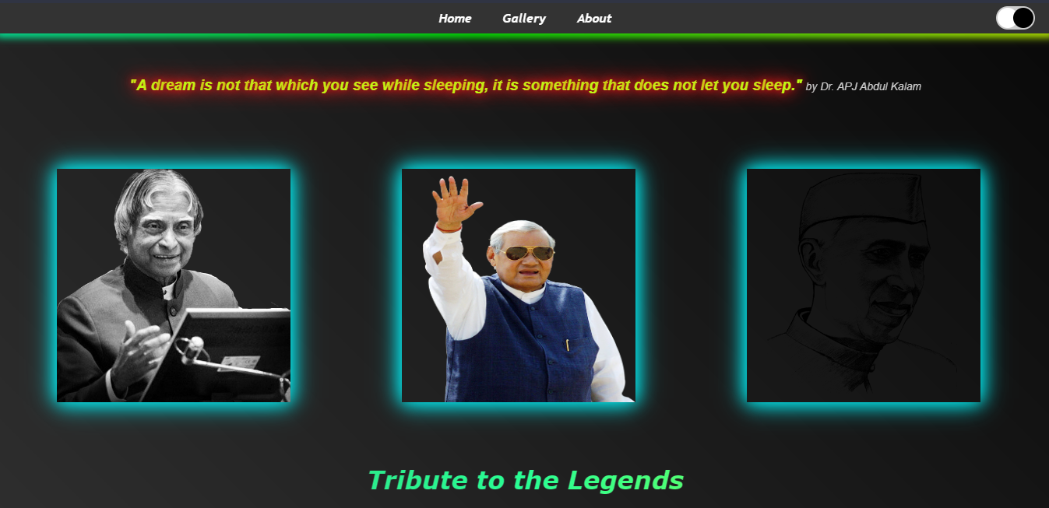

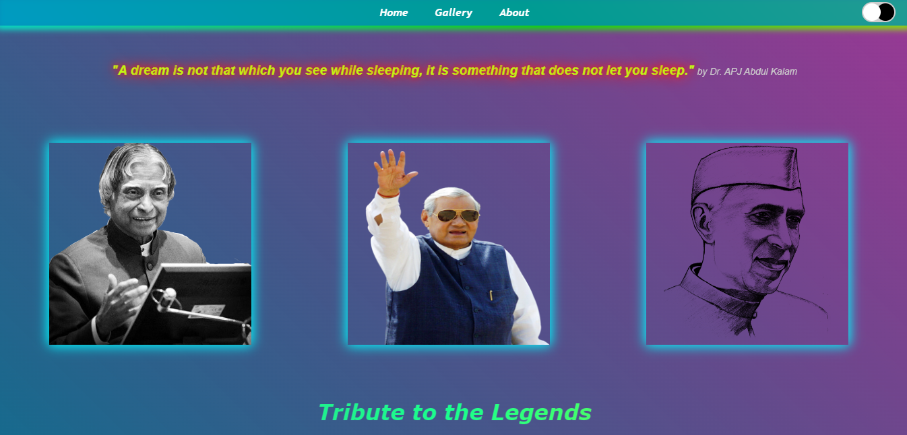

**(6)**

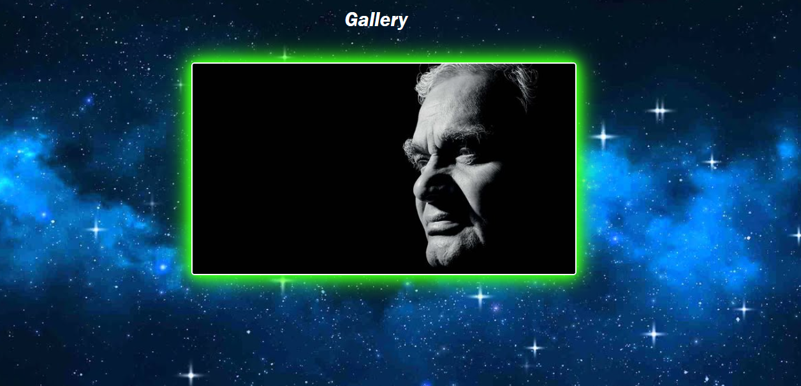

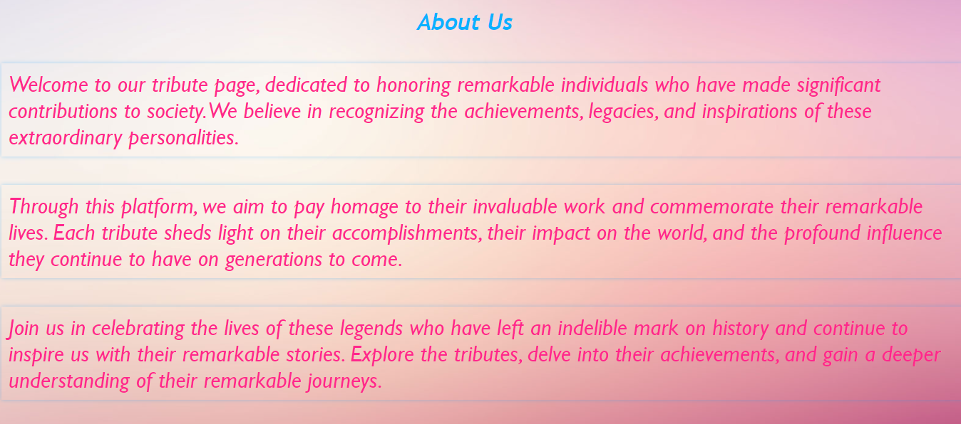

**(7)**

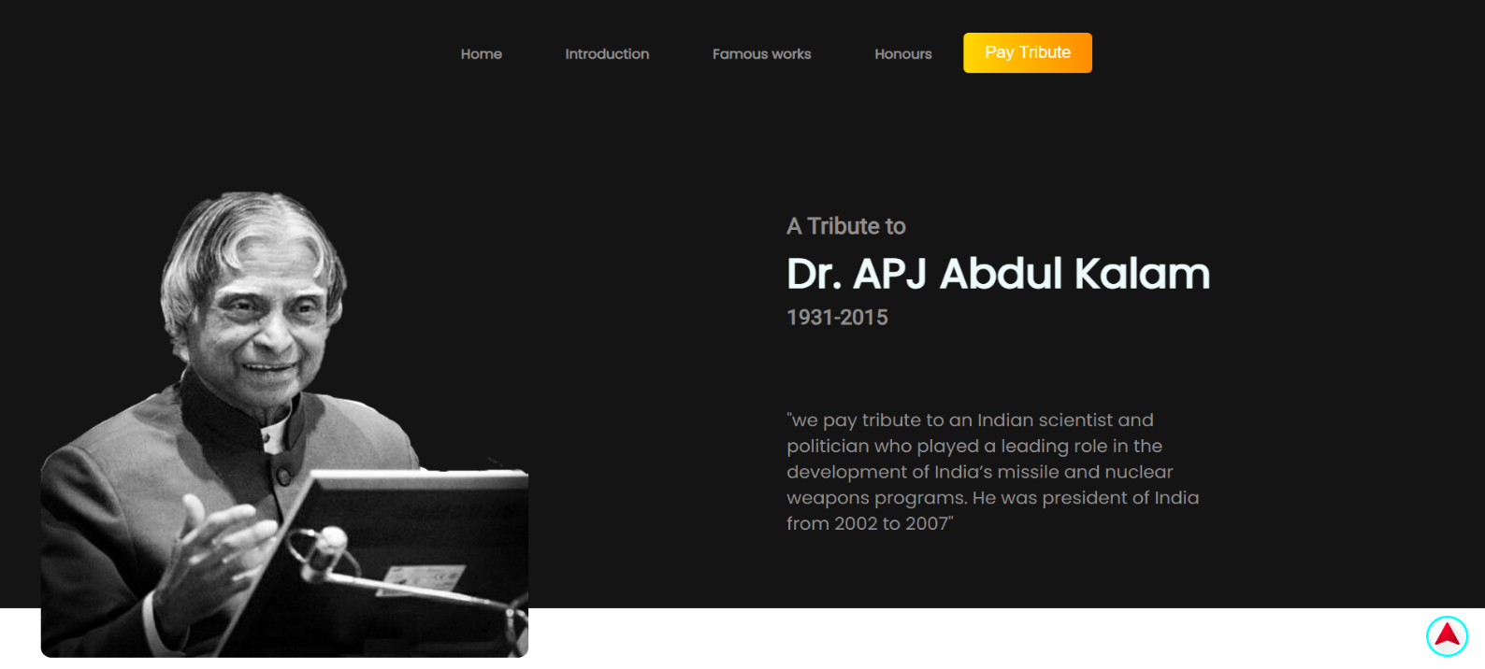

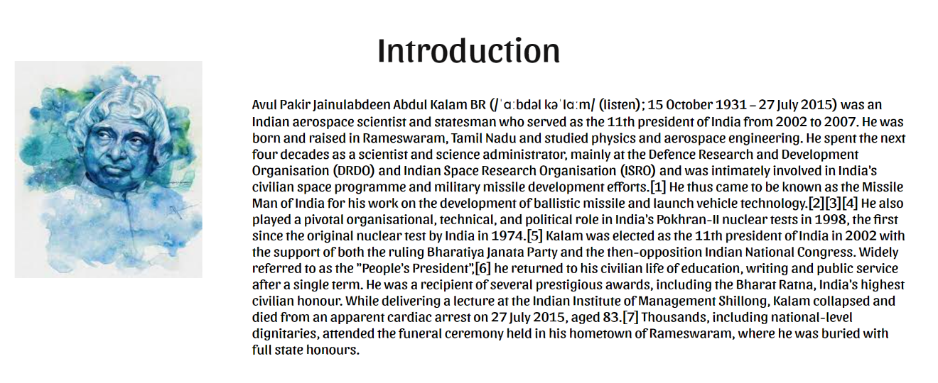

**(8)**

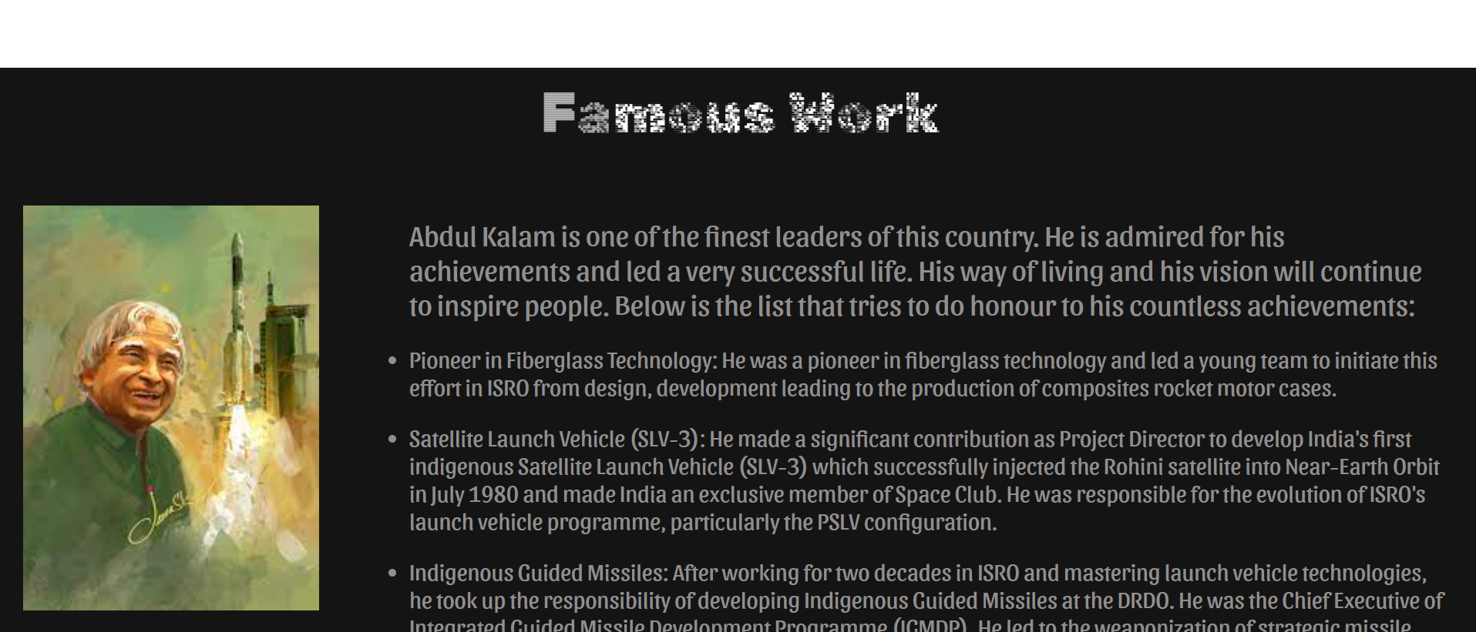

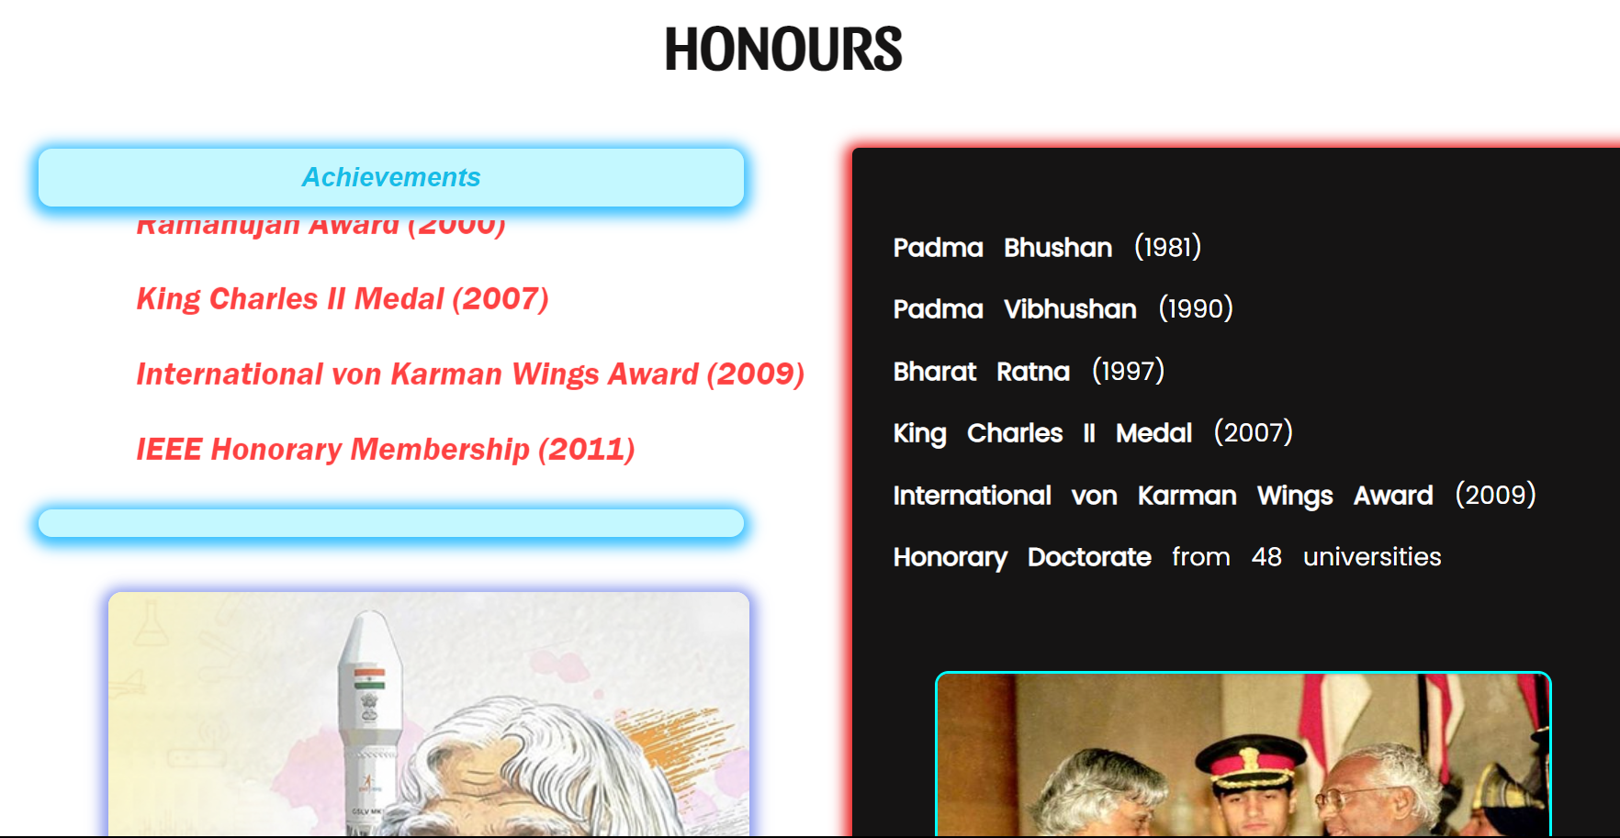

**(9)**

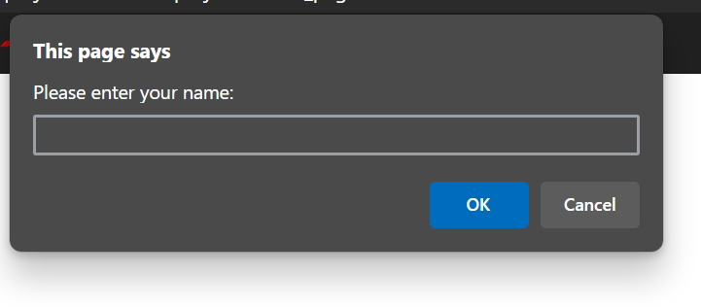

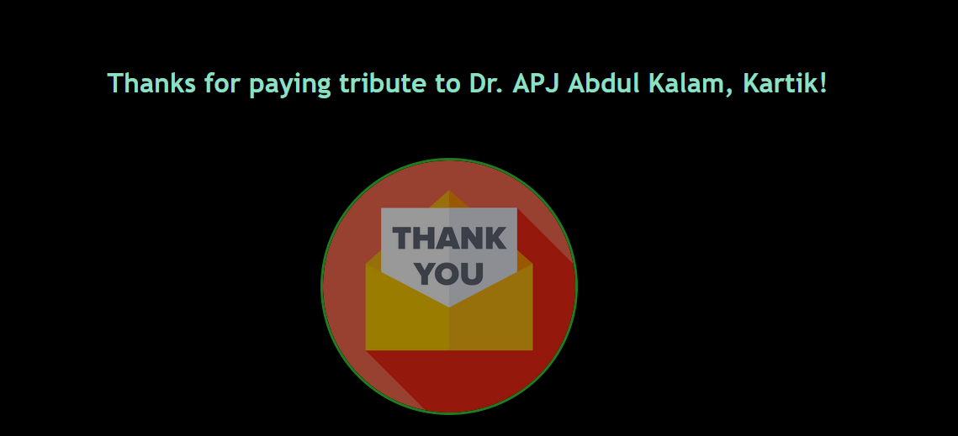

**(10)**

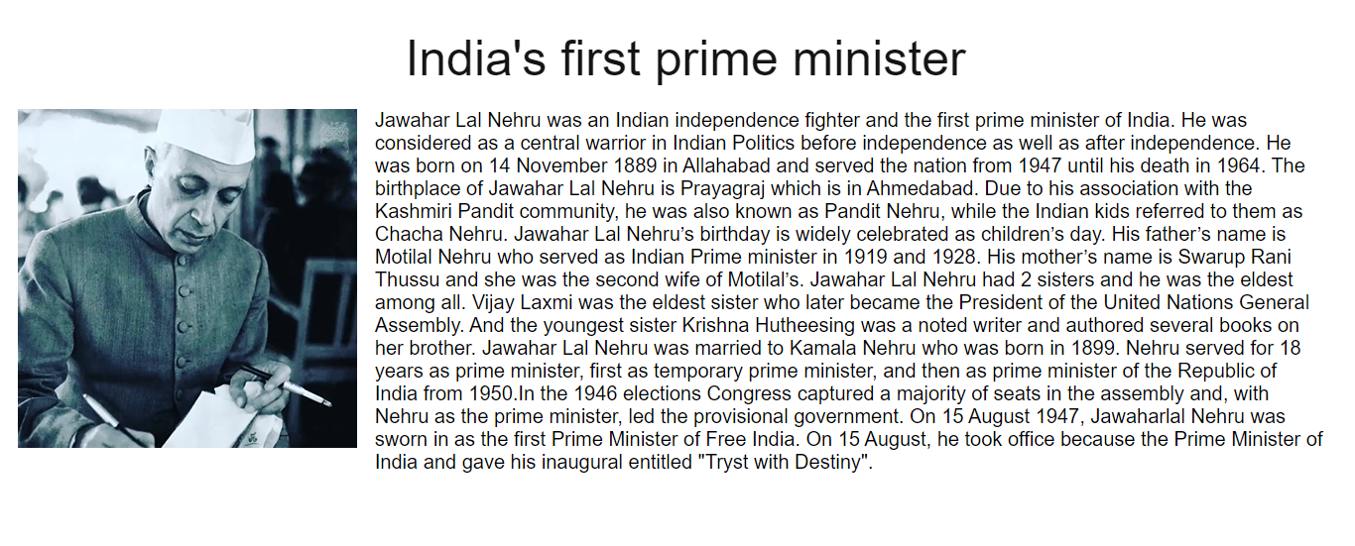

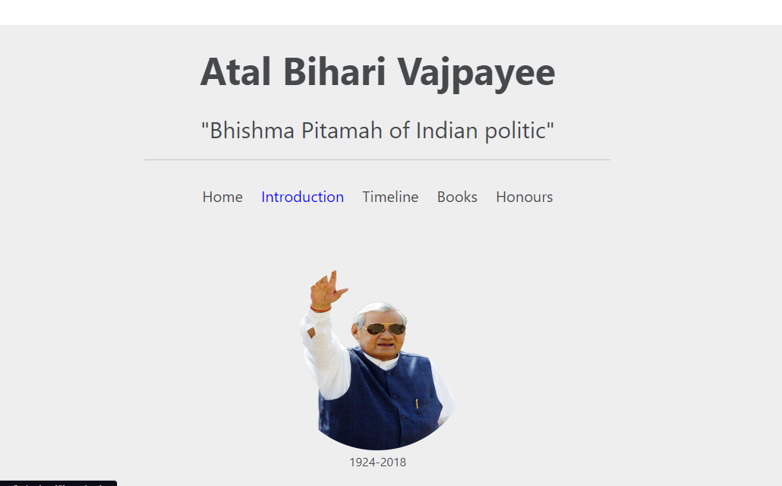

**(11)**

**Update Logs**

1. Created the basic HTML structure of the project, including the header, navigation menu, and three image containers for the individuals being honored.
2. Added CSS styles to the image containers to give them a glowing neon effect using box-shadow and animation properties.
3. Implemented JavaScript functionality to toggle the theme of the website using a theme toggle button in the navbar.
4. Added text captions below each image container to display the names of the individuals being honored. Styled the captions with attractive fonts and made them visually appealing.
5. Applied background images and colors to enhance the overall visual experience of the website. Used a glass texture to give a unique and aesthetic look to the about us page.
6. Added glows to the paragraphs on the about us page using CSS animation, creating an engaging and captivating effect.

**(12)**

**Development Process**

Development Process: The development of the Tribute Project involved the following steps:

1. **Requirement Analysis:** Gathered the project requirements and defined the scope and objectives.
2. **Design and Wireframing:** Created wireframes and visual designs to plan the layout and user interface.
3. **Front-end Development:** Implemented the project using HTML, CSS, and JavaScript to create the web pages and interactive features.
4. **Content Creation:** Gathered information, images, and multimedia content for each personality to present comprehensive profiles.
5. **Testing and Bug Fixing:** Conducted thorough testing to ensure the functionality and responsiveness of the project across different devices and browsers.
6. **Deployment:** Hosted the project on a web server to make it accessible to users.

**(13)**

**Future Scopes**

1. **Adding More Personalities:** We can extend the tribute project by including more personalities or legends in various fields like science, literature, sports, music, etc. This allows you to pay tribute to a broader range of influential individuals.
2. **Social Sharing and Community Engagement:** Implementing social sharing functionality allows users to share the tribute project on various social media platforms, spreading awareness and attracting more visitors. Additionally, creating a community section where users can contribute their stories, memories, or personal experiences related to the personalities can foster engagement and collaboration.
3. **Localization and Multiple Languages:** To reach a wider audience, we can consider adding support for multiple languages, enabling users to switch between different language options. This localization effort can help people from diverse backgrounds access and appreciate the tribute project.
4. **Responsive Design and Mobile Compatibility:** Optimize the tribute project for different screen sizes and devices, ensuring a seamless experience for users accessing it from various devices, including smartphones and tablets.

**(14)**

**Conclusion**

The Tribute Project serves as a digital platform to honor and appreciate influential personalities who have made a significant impact in various domains. Through its interactive and informative features, the project aims to inspire and educate users about these legends and their remarkable contributions. With ongoing development and future enhancements, the Tribute Project has the potential to become a comprehensive tribute platform that celebrates the achievements and legacies of renowned personalities from around the world.

**(15)**